Payload creation

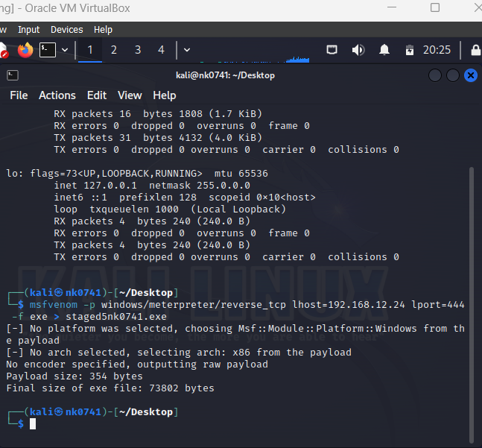

Running the msfconsole and getting the access to the windows machine:

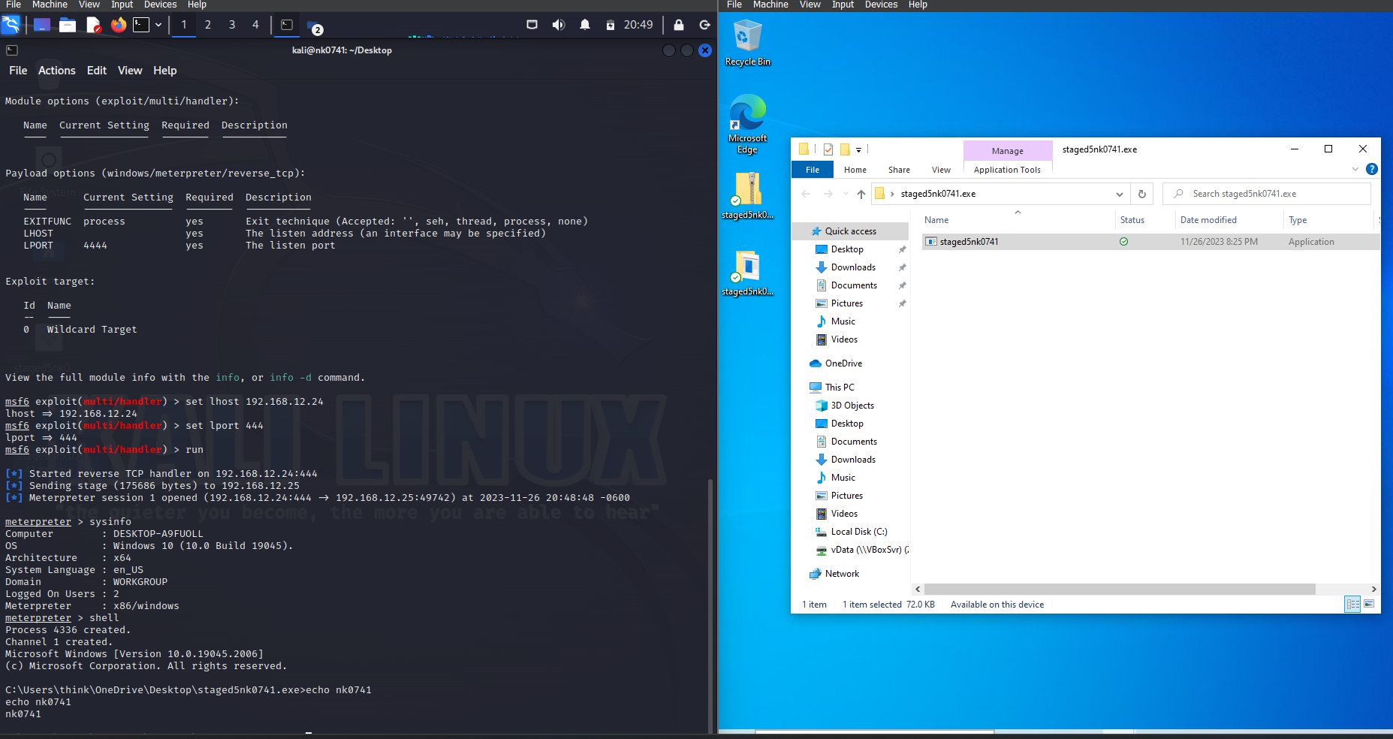

Setting the Firewall rule:

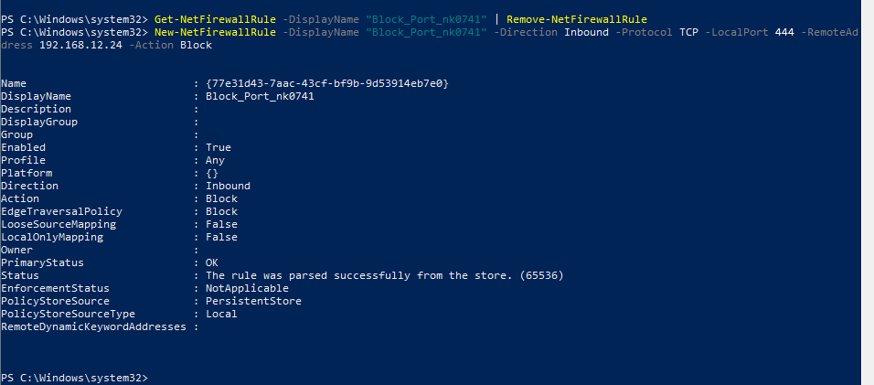

Running to the msfconsole to check if we have access are not.

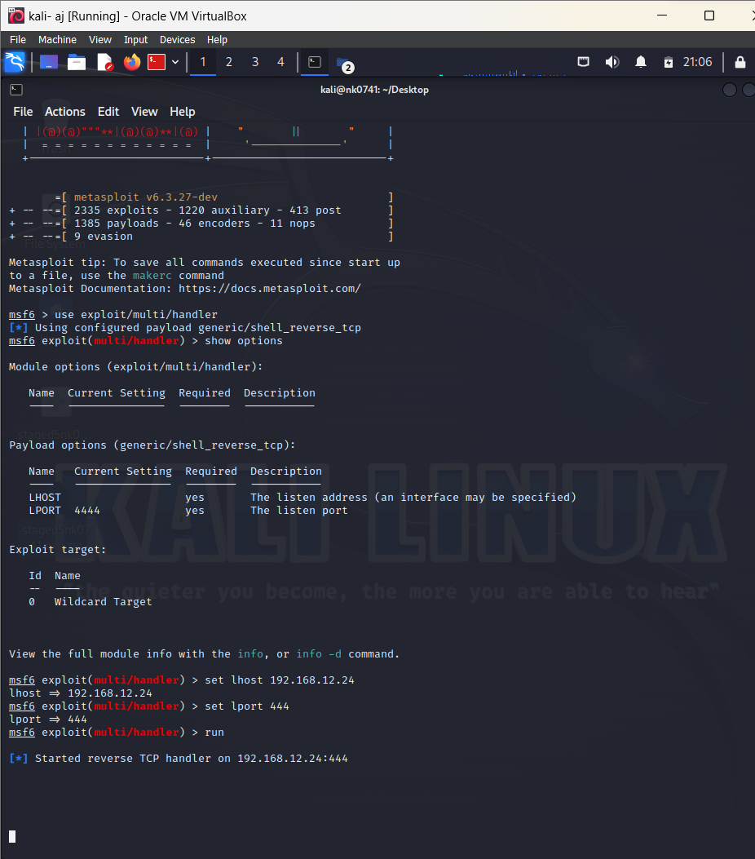

After waiting even for 30mins, I was not able to get connected to the windows. The connection is left like that.

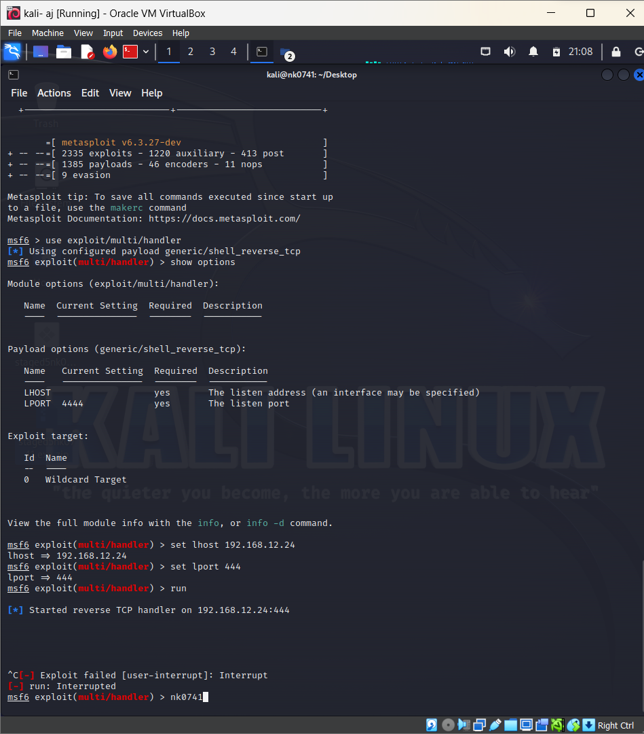

I canceled the connection using ctrl +c.

Removing the rule

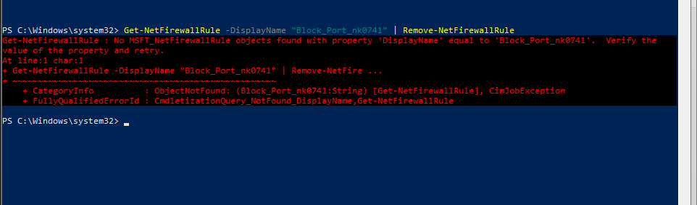

Able to connect once the rule is delted.

